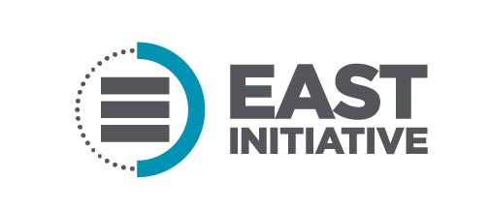

EAST JOB DESCRIPTION
JOB TITLE: Social Media Intern

SUMMARY: The Social Media Intern will design and develop a formal mentorship program for teachers nationally in collaboration with Facebook’s EdMod program.

ESSENTIAL DUTIES AND RESPONSIBILITIES:
- Develop an online social community (via Facebook Groups) for teachers to share resources, generate discussion, and promote collaboration across disciplines and geographical locations nationally.
- Design and implement a strategy around established goals for the program including the target number of teachers involved, engagement metrics, etc.,
- Recruit educators to participate in the group
- Collaborate with the EAST communications team, Site Support Coordinator for Education Unleashed and Training Specialist to develop and deploy a marketing strategy that will help grow engagement and participation in the Facebook group.
- Serve as backup moderator for the EAST/Edmod Facebook Group
- Recruit, coordinate, and train ten expert teachers to assist in growing engagement and to support the goals of the program
- Attend and co-lead a webinar to coordinate and train ten “expert” teachers in late March/early April
- Develop four posts to be sent out monthly to the Facebook group.
- Other duties as assigned.

QUALIFICATIONS:
- High school diploma
- Some college experience, with an emphasis in project management, education and/or communications
- Experience with Google Suite tools
- Strong communication and relationship building skills
- Ability to think creatively, take initiative, and work as part of a team
- Exhibits a positive attitude
- Must be organized and extremely detail-oriented
- Experience managing a Facebook Group preferred
- Non-profit experience, a plus
- Must have a current, unrestricted driver's license
- Ability to attend EAST events which often requires overnight travel

SUPERVISORY RESPONSIBILITIES:
- None

EDUCATION AND/OR EXPERIENCE:
- Previous internship or related experience a plus

LANGUAGE SKILLS:
- English language: including punctuation, spelling, grammar, and writing technique
- Excellent written and verbal communication skills

REASONING ABILITY:
- Ability to problem solve using deductive reasoning skills in a timely manner

MATHEMATICAL SKILLS:
- Basic skills including but not limited to addition, multiplication and division of whole numbers, decimals and fractions

PHYSICAL DEMANDS:*
- Ability to occasionally lift 35 pounds
- Ability to drive a car
- May frequently be required to stand, walk, use hands, reach, stoop, kneel or bend, talk, or hear

*Requests for accommodation need to be directed to Human Resources.

WORK ENVIRONMENT:
- Quiet to moderate noise level
- Fast paced, collaborative and positive

Signature Print Name Date

